Skylight
A classroom corpus resource for language learners

Andrew Dickinson
ajd@mailboat.co.uk
Gill Francis
gillian.francis@blueyonder.co.uk

Abstract
This paper reports on the development of a classroom corpus tool that will give teachers and learners an easy-to-use interface between them and the world of language out there on the web and in a range of compiled corpora. The application is intended to be used by UK secondary schools and first-year university students, as well as in EFL classrooms here and in other countries. It will enable teachers and learners to access a corpus during a class, whenever they want to investigate how a word or phrase is used in a range of real language texts and situations.

1 Overview
This paper reports on our ongoing project, Skylight, the purpose of which is to provide online corpus access in the English classroom. The emphasis will be on simplicity and clarity: the interface is colourful and uncluttered, and the application comes with a range of activities that provide plenty of opportunities for students to explore the language for themselves.
There has been a lot of enthusiasm for projects like this, notably by John Sinclair in the latter years of his life, when he was closely involved in the development of a corpus tool for Scottish schools, unfortunately not completed. As far as we know, however, there are no applications that are widely and routinely used in English classrooms. (Our knowledge is admittedly limited to the learning and teaching of English, and we would be interested to know more about similar projects in other languages.)
Our first interest is in getting a resource like this into secondary schools in this country, especially at Key Stage 3 level, where students no longer have to take national exams at the age of 13 or 14, since the recent abolition of the Standard Assessment Tests for this age group (SATs). We are interested in native-speaker education largely because it seems that at present, schoolchildren do very little work on language as such, or on the dreaded subject ‘grammar’. Grammar, after all, involves no more than understanding your language and being able to use this understanding in interesting and useful ways, but it is generally feared and avoided in favour of much more impressionistic approaches to the written and spoken language that children encounter, as well as the texts they are expected to produce.
However, it is likely that we will pilot the application in EFL classes initially, since this is a wider market and one that is much more receptive to new ideas and resources. There is also a lot more money being invested in EFL, and Skylight may initially find more friends here than in the native-speaker sector. But native-speaker classrooms remain our priority.
For initial guidance and ideas, the website will offer a large number of suggestions for stand-alone classroom activities practising points of grammar, lexis, and phraseology, and stressing their interconnectedness. The activities and ideas owe much to Data-Driven Learning, the pioneering enterprise of Tim Johns, which began as far back as the early 1980s. Such a corpus resource has the advantage of combining all aspects of language use: grammar and vocabulary (which are course are not separate phenomena at all) as well as phraseology, collocation, register and genre. It will also do something to counter the prescriptiveness of current approaches (especially in schools), by showing teachers and students that some of the most strictly-taught ‘rules’ do not always apply across the board to real language in use.
In the first part we will introduce the project and mention a couple of examples of the kind of language-learning resources that will accompany the application. The second part will briefly describe the computer technology behind Skylight.

2 Corpora
The Skylight application accesses both external proprietary licensed corpora through the internet, as well as our own compiled corpora on our servers. The important point here is that whichever corpus the user sends their query to, the output looks exactly the same on the user interface – the Skylight screen.
The existing corpora we will use may include:
- ukWaC
- the Leeds collection of internet corpora http://corpus.leeds.ac.uk/internet.html (subject to agreement)
- out-of-copyright literary works (including GCSE set books, Shakespeare, collected poems)
- the Bank of English (some part of this, subject to availability)
- the BNC (as a historical snapshot)
- corpora of learner English, eg the International Corpus of Learner English (Sylviane Granger)
- other corpora currently becoming available, such as BiWeC - Big Web Corpus (Adam Kilgarriff et al.)
We are also in the process of compiling our own corpora, using WebBootCaT (Adam Kilgarriff, Boroni et al.). Further details of this are given in section 7.5. In the longer term we hope to compile tailor-made corpora; for example we need to cater for various groups of users, such as native-speaker children, university students in language and linguistics courses, and EFL learners. We are also investigating the use of corpora of learner English. More details of available corpora will be available on the Skylight website. It has to be said, however, that our achievement to date has not matched our ambitions, and further details will be posted on the website as available.

3 Skylight: features of the query screen
3.1 The user interface: query-level operations
A major priority is simplicity of use, so Skylight has a very stripped-down, uncluttered user interface compared with other corpus access applications. It is designed to be used by anyone with basic computer skills of the point-and-click, internet-search variety, but we do not assume any prior experience of using a corpus for investigating or learning a language.
Another priority is the avoidance of technical terms, since these can be very off-putting to people not familiar with any of the terms that are freely used among corpus linguists. We have even avoided terms like lemma, concordance, collocation, and node, though these are explained and used systematically in the accompanying resources. The only slightly ‘different’ terms we have used on the first screen are wildword, which is fairly obvious (and defined in a pop-up), and output, which is self-explanatory.
Unavoidably, simplicity involves certain restrictions on output, which are explained below. Figure 1 is a demonstration screen showing the main query-level features of the application. There will of course be far more corpora available than shown here, and they will eventually appear on a drop-down menu.

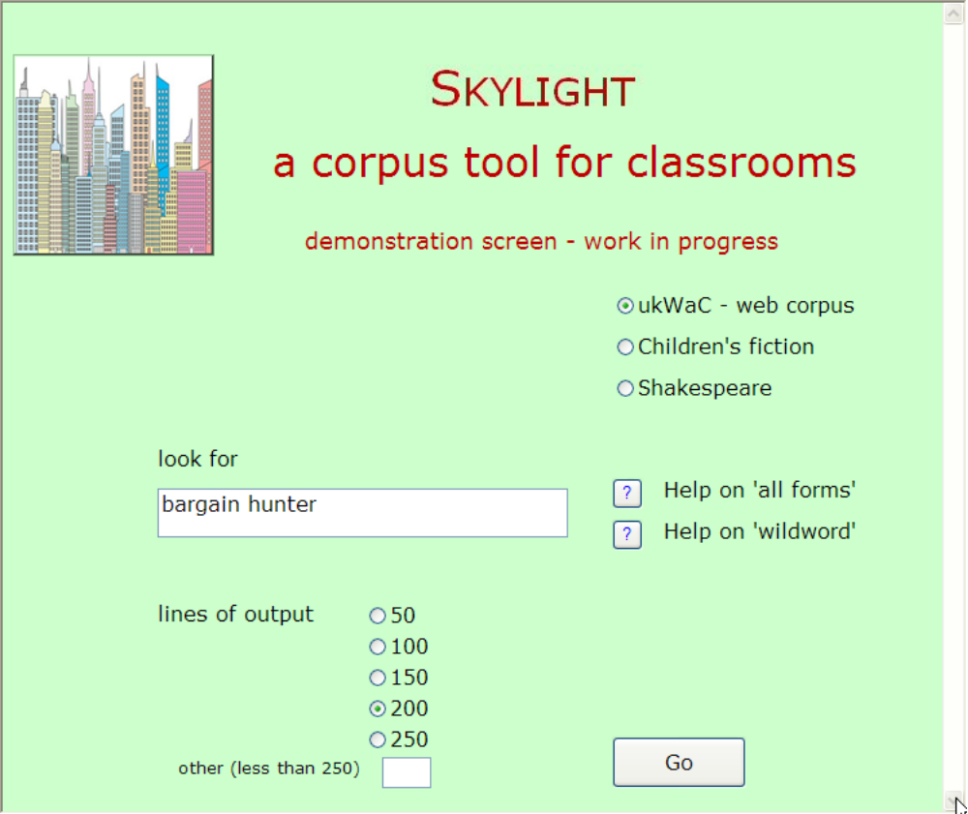
Figure 1: The Skylight query screen

3.1.1 Corpus selection
The top set of option buttons offers the user a choice of available corpora, as on any application such as Sketch Engine or the Bank of English. In the first version of the application, it will be possible to select only one corpus. This is to allow teachers to control output, as they can ask students to select the corpus relevant to a particular class or teaching point. Figure 1 above indicates that the user has selected the ukWaC web corpus.

3.1.2 The ‘look for’ window: phrases, lemmas, and ‘wildwords’
The user can now make a query – a word or a phrase – again as is standard. This is typed into the window as usual, eg bargain, bargain hunter, bargain basement prices etc, with normal spacing.
The user can choose to receive output for ‘all forms’ of a word, ie a lemma, by typing in a hash sign after the relevant word or words:
- bargain price# returns bargain price and bargain prices
- pop# up returns pop up, pops up, popped up and popping up
- attract# the attention# of returns all forms of attract and both singular and plural forms of attention
In the first version of Skylight, the hash sign has to be typed in manually. In future versions, we expect that if the query is a phrase, the user will be able click on the word or words for which they require ‘all forms’. A hash sign will appear after the word automatically to record the selection,
There is also a ‘wildword’ option, up to a maximum of two words, each indicated by an asterisk surrounded by spaces. (This of course must be distinguished from a wildcard in other applications, which returns all possible characters, usually at the end of a string, and is not preceded by a space, eg combin*.) In Skylight, one asterisk returns output with either zero or one intervening word, and two asterisks return output with zero, one, or two intervening words:
- on * terms returns on terms, on good terms, on equal terms etc
- on * * terms returns on terms, on good terms, on my/his/her own terms, on very good terms etc
Of course, it is also possible to combine both the ‘all forms’ and ‘wildword’ options, for example waste# * time, but this is the most complex type of query, and not necessarily ideal for beginners. In any case Skylight will not get more complicated than this; we aim to use as few symbols as possible.

3.1.3 The Help buttons
To the right of the ‘look for’ window are two Help buttons, as shown on Figures 1 and 2. When clicked, pop-ups appear that explain how to request ‘all forms’ and ‘wildwords’. For example, the pop-up Help on ‘all forms’ gives a box reading “Put # after a word to request all forms, eg find# will return lines for find, finds, found, finding.”.

3.1.4 Amount of output
One major compromise has been made for the sake of simplicity: the user will be able to ask for a maximum of 250 concordance lines. Arguably, it is not necessary for students to access more than this for any one word or phrase, and a larger number of lines may well be daunting to people new to this type of application.
From a practical point of view, too, there seems little point in overloading the local network and the Skylight server with extra work. There is always the danger that a student may accidentally or deliberately request 20,000 lines for the word of.
Figure 2 below shows the options: the user can select 50, 100, 150, 200, or 250, or another number so long as it is less than 250.

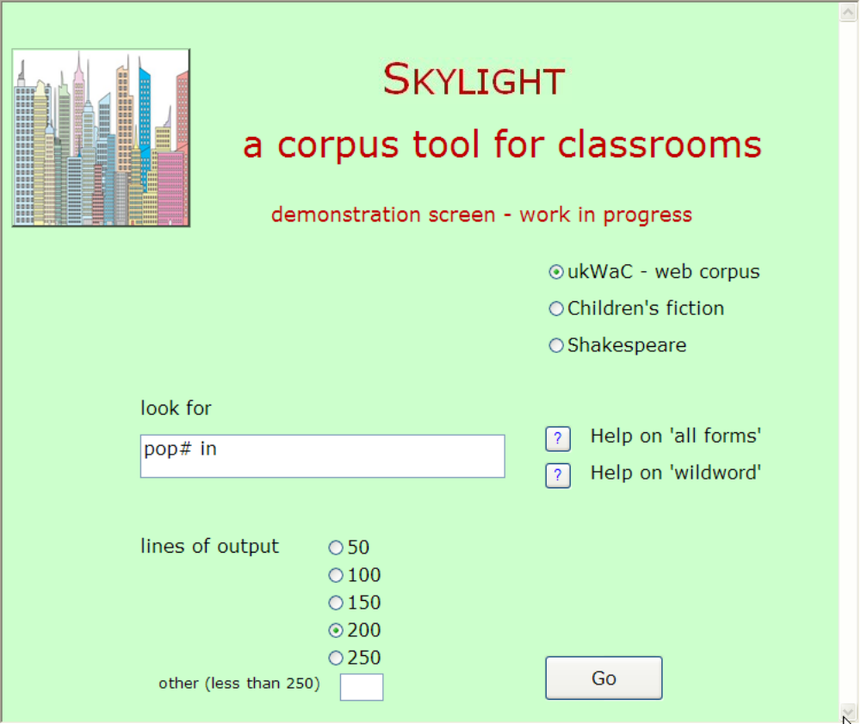
Figure 2: The Skylight query screen (2)

4 Skylight: Operations on the output
As on standard applications, Skylight offers various options after the initial output has been returned. The difference is that there are rather fewer options; we are prioritizing those that are most often used – though for this we are relying on personal experience rather than any proven facts.

4.1 Alphabetical sorting
For the sake of simplicity, output can be sorted up to three words to the right or to the left, not more. In the case of phrases and other chunks, further sorting options may be desired, but we see this restriction as a necessary compromise. There will be no secondary sort – the applications will not be sophisticated in the way that Sketch Engine or WordSmith are.
The sorting options will probably be presented as option buttons on the first output screen.

4.2 Line expansion
The user can click on the node word of any line to expand the text and give a bigger context – currently 30 words on either side of the node. This is of course absolutely essential and a standard feature of concordancers.

4.3 Document identification
As in Sketch Engine, the user can click on any line (in our case the line number) to find out where it comes from, eg the Times, or a particular novel.

4.4 Line deletion
The user can click anywhere else on any line, which highlights the whole line. Pressing the Delete key on the keyboard will get rid of the line in order to reduce the output in ways the user chooses. (See Section 4.5 below for an example.)

4.5 Sample output
By way of summarizing these output options, Figure 3 shows an output screen for the phrase on * terms (from ukWaC). This was originally a 60-line sample, which has been sorted one word to the left. All lines containing on terms have been deleted, so that the user is left only with lines where there is one intervening word between on and terms. (There were 40 lines remaining, of which this slide shows lines 6-24.)

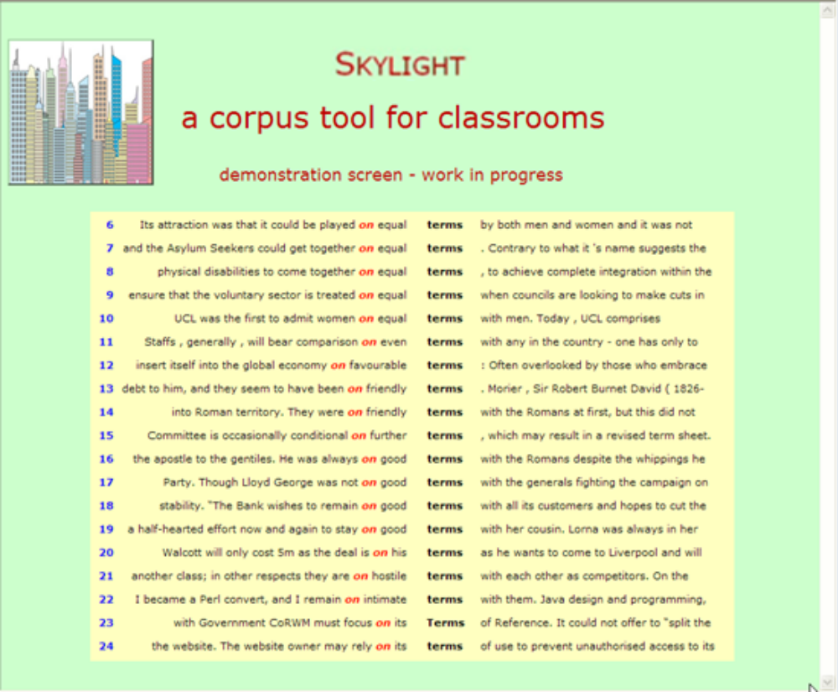
Figure 3: Sample output

5 Collocation
The user will also be able to get information on collocation. This view, which we are calling ‘searchlight’, is modelled on an extremely neat and useful feature of Cobuild’s Bank of English, where it is called ‘Picture’. ‘Picture’ is far more sophisticated than ‘searchlight’, but the principle is the same. The output screen lists the collocates in unrelated vertical columns showing where a particular collocate typically occurs in relation to the node, ie first to the right, second to the right, first to the left etc. The maximum is three words each side, ie the same number as the sort option. Unlike the Bank of English software, however, there will be no statistical information; the collocates will be listed in order of significance (T-score), but no further information will be given. It is unlikely that new or inexperienced corpus users will understand the statistics, and in any case Skylight is not aimed at those who do. Figure 4 shows the sort of output produced by ‘searchlight’. Again, there will be an option button on the first output screen that toggles between the concordance line view and ‘searchlight’.

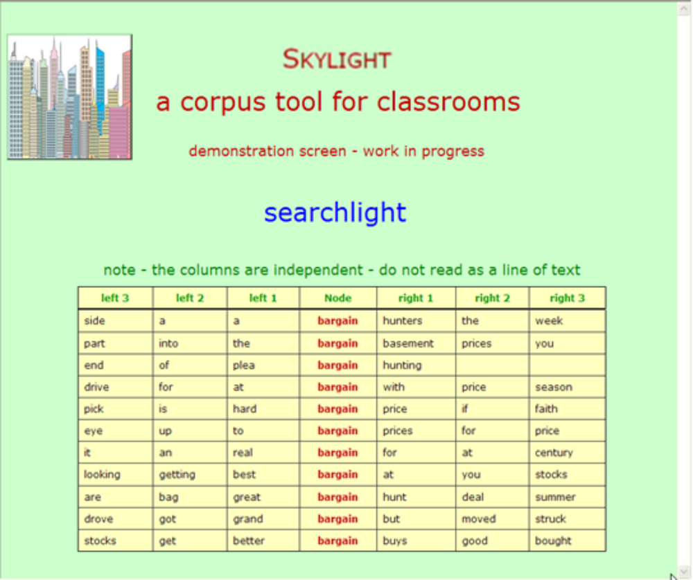
Figure 4: Collocation – the ‘searchlight’ view

The user can also select certain lines from the ‘searchlight’ output, by clicking on the relevant collocate. So if the user clicks on the word hard in Figure 4 (the fifth most significant word first to the left of the node), the following lines are returned:

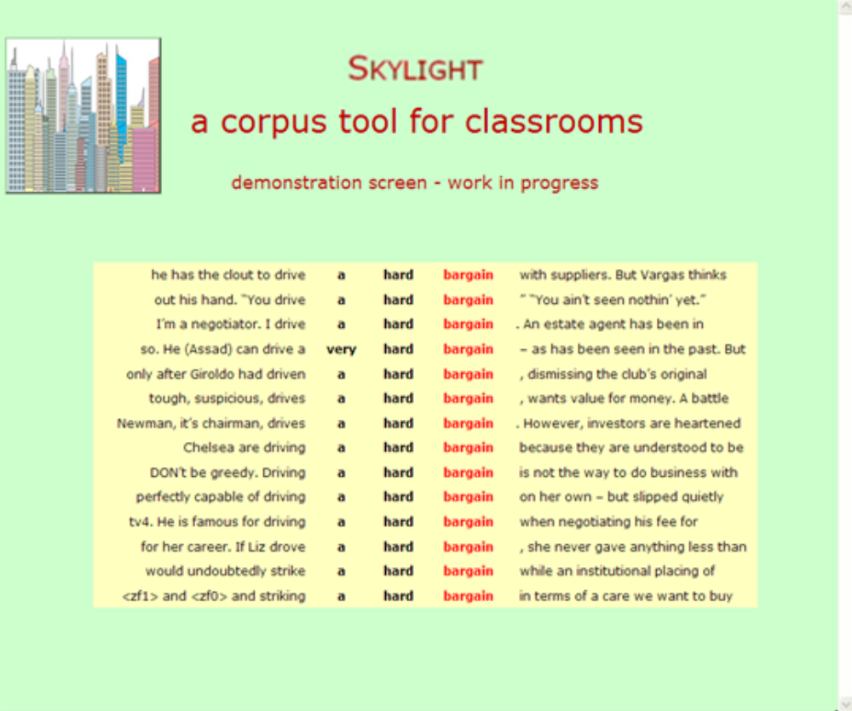
Figure 5: Selecting lines from the ‘searchlight’ view

6 Resources for teaching and learning
When Skylight is launched, it will come with a simple user guide for teachers, and an even simpler one for students. There will also be a set of basic resources for teachers to use when they start out, to give them confidence in using concordances in the classroom. The first set of resources (Activities Pack 1) is targeted at intermediate to advanced level EFL students; the second – in preparation – is designed for native-speaker schoolchildren aged 13 and above (Key Stage 3 and GCSE levels). These resources will be posted on our website but will also, we hope, be available in print (A4, photocopiable).
As an introduction for teachers and students, there will be a collection of worked-through examples, based on particular words and particular words and phrases. This will consist initially of a set of 50–100 classroom activities that cover key language points, each taking anything from ten to 30 minutes. They are organized into broad categories, an overview of which will be provided on the website. To give just a few examples, there is a series of activities exploring the collocates of common ‘delexicalized’ verbs (make a choice, have a look, give a reason); another series looking at several of the chunks often known as ‘complex prepositions’, such as ‘in terms of’, ‘ahead of’, ‘according to’; and another focusing on verbs like ‘change’ and ‘break’ (which are often called ‘ergative’ verbs). And in the native-speaker pack there is a thread that addresses language change and the tension between description and prescription in language teaching – one activity focuses on changing pronoun use in English (eg they as a general pronoun to replace he or she; the shifting use of subject and object pronouns – Alena and I left together / Alena and me left together / Me and Alena left together). Teachers and learners will be able to use these resources as a springboard for developing their own approach to looking at language.
There are various types of activity, most of them well-known to classroom teachers. For example, Figure 3 above gave a sample of the lines returned for the query on * terms. There are many ways of exploring this phrase; Figure 6 below gives all 40 lines:
1 | by way of a commercial loan on commercial | terms | or applied by the Trustees for investment
2 | market diversification: Venture capital on easy | terms | and low interest rates; Assistance in
3 | to emphasise that it had to be justified on economic | terms | . That had not changed. In answer to
4 | second half and within a minute were back on equal | terms | with the Reds. City broke down the left
5 | of disabled and non-disabled people on equal | terms | . More information on the awards
6 | Its attraction was that it could be played on equal | terms | by both men and women and it was not
7 | and the Asylum Seekers could get together on equal | terms | . Contrary to what it 's name suggests the
8 | physical disabilities to come together on equal | terms | , to achieve complete integration within the
9 | ensure that the voluntary sector is treated on equal | terms | when councils are looking to make cuts in
10 | UCL was the first to admit women on equal | terms | with men. Today, UCL comprises
11 | Staffs, generally, will bear comparison on even | terms | with any in the country - one has only to
12 | insert itself into the global economy on favourable | terms | : Often overlooked by those who embrace
13 | debt to him, and they seem to have been on friendly | terms | . Morier, Sir Robert Burnet David ( 1826-
14 | into Roman territory. They were on friendly | terms | with the Romans at first, but this did not
15 | Committee is occasionally conditional on further | terms | , which may result in a revised term sheet.
16 | the apostle to the gentiles. He was always on good | terms | with the Romans despite the whippings he
17 | Party. Though Lloyd George was not on good | terms | with the generals fighting the campaign on
18 | stability. “The Bank wishes to remain on good | terms | with all its customers and hopes to cut the
19 | a half-hearted effort now and again to stay on good | terms | with her cousin. Lorna was always in her
20 | Walcott will only cost 5m as the deal is on his | terms | as he wants to come to Liverpool and will
21 | another class; in other respects they are on hostile | terms | with each other as competitors. On the
22 | I became a Perl convert, and I remain on intimate | terms | with them. Java design and programming,
23 | with Government CoRWM must focus on its | Terms | of Reference. It could not offer to “split the
24 | the website. The website owner may rely on its | terms | of use to prevent unauthorised access to its
25 | of disability would need to lead their lives on level | terms | with non-disabled people. These examples
26 | pricing. Contact For further information on licence | terms | and prices, to order samples of any of our
27 | made it clear that that I would accept the post on my | terms | and that it would not be entirely
28 | staff working there would be seconded on NHS | terms | and conditions. Asked about the role of
29 | and Malmo keeper Lee Baxter on non-contract | terms | . Warnock will choose between the pair for
30 | attract staff and compete for customers on other | terms | rather than wage levels. Whilst there is
31 | shares in the employing company, on preferential | terms | . Participating employees may save
32 | that they should be entitled to it on self-defining | terms | “to all trans people? I don't think so. To
33 | Pericles and Mariana never met on speaking | terms | . Even granted Pericles left Mariana with
34 | class one were new books lent on subscription | terms | ; after 4 years they were re-classed second
35 | of the Owl newspaper to be competed for on such | terms | as the Council may fix. Out of
36 | the overall journey. His decision was based on the | terms | of the air waybill itself. The judge regarded
37 | before ending your employment. Depending on the | terms | of your contract, notice can be worked or
38 | than later, and don't hold the club to ransom on the | terms | either. Recognise that your - yes your -
39 | of how we continue to reach consumers on their | terms | , regardless the time, location or device.
40 | All orders that you place with us will be on these | terms | (or any that we may issue to replace them).
Figure 6: Output for on * terms (one intervening word)
Both students and teachers might find the lack of context daunting at first, especially as some of the lines contain incomplete and mysterious sentences. It is important that they learn how to ‘read’ the display – the trick is to look at the node word and go outwards to the left and right to make the sense, rather than trying to read from left to right as usual. When the student is accessing the corpus directly, there is always the option of expanding the line, but with practice it is usually possible to tell roughly what it is about and to make interesting observations without expansion.
There are many points for discussion in these lines. In the resources pack, a 100-word sample is used, but on the basis of just the 40 lines in Figure 6, students could:
- find the main pattern: on + adjective + terms
- spot the main adjectives to the left of the node: equal, friendly, good
- spot the adjective in this slot that means ‘bad’ or ‘unfriendly’
- identify adjectives that are near-synonyms or related in meaning: commercial and economic; even and level
- spot some other fairly fixed phrases: on speaking terms
- find the second most important pattern: on my/its/the/their/these terms
- find examples of the pattern on + noun + terms: nouns to the left of the node are licence, non-contract, subscription
- find the ‘odd ones out’, eg 23 …must focus on its terms of reference, 24 the website owner may rely on its terms of use, 36 based on, and so on. Here the word on ‘belongs to’ focus or rely and has nothing to do with terms.
The next example is a sample of output for ‘all forms’ of pop + in (Figure 7):

1 | and the Café Spice Namaste trademark cuisine. | Pop | in for a lunch or business meeting, and if
2 | is that children can learn through games, and also | pop | in and do their homework. It 's all about
3 | Johnny chopped the onions in the background and | popped | in the occasional helpful comment. We
4 | 23 firemen from Avon Fire Brigade will be | popping | in to see them at 11am.
5 | around us have been very friendly, they have been | popping | in to see us” she says, “Romsey is a lovely
6 | service station sells Shell Advanced Low Lead by | popping | in or calling Freephone to the Shell
7 | in style, lots of comfortable pastel colours. You can | pop | in for a meal, (pretty good brasserie styled
8 | for them remains with yourselves, as parents. Do | pop | in and take the opportunity to meet other
9 | alarm and fire extinguisher on the wall. Apart from | popping | in the other essentials like a toaster, kettle,
10 | exclaimed Mike. “Tell you what then, why don't I | pop | in a turbocharger, do a trendy paint job
11 | finished early, which is always a good sign, so I | popped | in to do a few bit parts myself. I 'm
12 | was there a mountain of unsold Daily Post’s when I | popped | in to Tesco at about 9pm? A major
13 | Interiors and Jewellery is clearly not a place for just | popping | in and out of, make sure you put enough
14 | practical help with shopping or gardening, or just | pop | in for a chat. People taking on a caring
15 | have gone to their GP for such treatment, but may | pop | in to their local pharmacy to pick up a
16 | if you are in the vicinity over the weekend why not | pop | in and view your personal message or
17 | help you. People are welcome, even if you can only | pop | in for a minute or two in those times. This
18 | the keys in the ignition whilst paying a petrol bill or | popping | in to do an errand and someone steals your
19 | please call 0871 7211865 on Monday morning or | pop | in in person at the Ticket Office. “We do
20 | good company, mutual support freely given. Please | pop | in - you will get a warm welcome and light
21 | naturally over time. To maintain the benefits simply | pop | in about once or twice a year and pamper
22 | to come and pay us a visit. Don't mind if they | pop | in to the nursery and take a peek at the baby
23 | with events in the search engine field, feel free to | pop | in and have a look at my web log (well,
24 | experience in the fitness industry. Please feel free to | pop | in for a chat or telephone me on 20553001 or
25 | know where and when to find me and feel free to | pop | in for a chat and cuppa! Needless to say,
26 | worth a visit in its own right. A good place to | pop | in for Sunday lunch. Motoring after
27 | value lunch & early supper menus that allow them to | pop | in for a plate of homemade pasta & some
28 | see them again next term as they're happy for us to | pop | in whenever to borrow books, what nice
29 | TUESDAY!!! Thanks for your replies girls. I will | pop | in from time to time to let you know how I’m
30 | stole ours from! Just kidding! Just thought I would | pop | in and say hello. I know some of you but
Figure 7: Output for pop# in (‘all forms’) from ukWaC

On the basis of just these 30 lines – again a larger sample is used in the resources pack – students could be asked to make observations about the meanings/uses of pop in. These are some of the points that can be made:
- The lines show that the ‘phrasal verb’ pop in is very often spoken rather than written, or is used in a chatty encouraging text, for example in a brochure or a flyer for a service. This is deducible from 13 and14 just pop in, 23–26 feel free to pop in, please pop in, and 16 why not pop in… and others. It seems to have this social function in many cases, as a larger sample confirms. In this respect it differs from related verbs such as ‘visit’, ‘come in’ and so on, though ‘drop by’ and ‘look in’ are also relatively informal.
- The fact that it is so often spoken helps to explain the distribution of the forms. There are only 3 lines for popped – suggesting that you don’t often report yourself or anyone else as having popped in, though this is a question of relative frequencies only. There is no line for pops in this small sample either, for related reasons.
- The verb pop in has a general prosody (in one at least of the many definitions of the concept) to do with something being easy, breezy, no trouble at all, as shown in 13 and 14 just pop in, 21 simply pop in, 17 even if you can only pop in for a minute or two…, 30 just thought I would pop in to say hello, and others. The other verbs like ‘visit’ or ‘come in’ lack this flavour, though ‘stop by’ may be similar in some ways.
- Some of the lines are slightly different in meaning – and have a different pattern. Here the pattern is ‘pop something in something’ as in line 10: Tell you what then, why don’t I just pop in a turbocharger, do a trendy paint job…
The activities are course far more developed than the brief examples given here.
It is envisaged that initially, students and teachers will focus on the worked examples, to familiarize themselves with this kind of language investigation. A large part of the resources accompanying Skylight, however, will suggest hands-on classroom activities, where the students type in queries themselves and work on real output. These activities will be posted on the website, initially for piloting purposes. Access to the pilot version of the application is expected to be available by late November of this year.

7 The technology behind Skylight

7.1 Basics about the internet, browsers, and web servers
Modern desktops and laptops have built into their operating systems an application called a ‘browser’. In Microsoft Windows this is of course Internet Explorer.
When a user types the address of a website, eg www.whatever.com, into a browser, their computer is connected through the internet – a world-wide network of computers – to another computer specified by that address. A computer that is accessed through a website address is called a web server. That web server sends back a string of text and the user’s browser fashions it into a web page on the screen.
When the user types or clicks on this web page, the browser sends a string of text, a request, to the web server according to what the user does on the web page; software on the web server decodes the request and makes up a string, the response, to send back to the user’s computer. The user’s browser then decodes this response string into a new web page – for example, when you type the search corpus linguistics into Google, the browser sends this text to the google web server:

search?hl=en&rlz=1W1ADBR_en&q=corpus+linguistics&meta=
and the server sends back a long string that begins

<!doctype html><head><meta http-equiv=content-type content="text/html; charset=UTF-8"><title>corpus linguistics - Google Search</title><script>window.google={kEI:"0OrESrKwH8aJ4Qb7j4BF",kEXPI:"17259,18167,21589,21668,21766,21920,21941,22023,22044,22093,22099,22114",kCSIE:"17259,18167,21589,21668,21766,21920,21941,22023,22044,22093,22099,22114",kCSI:{e:"17259,18167,21589,21668,21766,21920,21941,22023,22044,22093,22099,22114",ei:"0OrESrKwH8aJ4Qb7j4BF"},kHL:"en"};window.google.sn="web";window.google.timers={load:{t:{start:(new Date).getTime()}}};try{window.google.pt=window.external&&window.external.pageT;}catch(b){}window.google.jsrt_kill=1;
</script><style>body{background:#fff;color:#000;margin:3px

This text, some 30,000 characters in all, has everything the browser needs to make up the web page of search results. The same basic browser / web server communication is used in Skylight.

7.2 The Skylight web server
The Skylight application will be installed on a computer in a data centre somewhere (the geographical location is irrelevant, though there are considerations of speed) – a secure, cooled, high-speed internet-linked home for web servers.
To us, this Skylight computer – our server – looks like any other networked computer in an office. We can copy files from our development computers to the server, and get files from the server back to us; we have complete control over what is there. It is on this server that we install the files that are required for the website.

7.3 Concordancing in Skylight
The user connects to Skylight by typing the web address, and the web server sends back the query page, as shown in Figure 1 above.
As an example, the user types bargain into the Skylight query page on their computer, and their browser makes up a text string that includes this word and any other options set by the student or teacher. When the Enter key, or Go button on the web page, is pressed to complete the query, this text goes to the Skylight web server. The Skylight software translates the request into the query language of a concordancer. At present we are using Xaira for reasons described in section 7.5 below.
The Skylight server sends this query to the concordancer, which then connects to the corpus requested by the user, be it on the web or installed locally on the Skylight server computer. Output from the corpus comes back into the Skylight software, via the concordancer, as a collection of strings of text, the concordance lines. Finally, the Skylight software works on this text to make up a web page, and sends it down to the user’s computer.

7.4 Which concordancer, which corpus?
The ideal solution would be to find one concordancer that would work with all of the corpora we want to use. We are only querying a word or phrase, getting a maximum of 250 lines back, and not allowing many options. We are not trying to provide extensive analytical tools, so the concordancer does not have to be very sophisticated.
A big priority is to supply output that reflects absolutely up-to-date language use, so we want to use corpora that are the most current, trawled-up-from-the-web. Of the ready-made web corpora we have found, one we are using is ukWaC, which is
a large corpus of English constructed by crawling the .uk Internet domain. The corpus contains more than 2 billion tokens and is one of the largest freely available linguistic resources for English. (Boroni et al.).
This is now a few years old, but Adam Kilgarriff and others are working on a much larger web corpus (BiWeC - Big Web Corpus - currently of 5.5b words, with a target size of 20b) which we hope to use (subject to agreement with the compilers) when it is available.
We will be also compiling our own specialized corpora along the lines suggested in section 2 above, using the tool WebBootCaT. This allows us to select seed words and crawl through web sites collecting corpus material.

7.5 Xaira - XML Aware Indexing and Retrieval Architecture
Xaira was developed by Lou Burnard and Tony Dodd at Oxford University Computing Services (begun 2005 with development ongoing). It is based on SARA, a text-searching system originally developed for searching the British National Corpus.
Because the source-code is available and distributed free of charge under the GNU General Public Licence, Xaira is particularly useful for us because:
- we can build the Skylight server software with the Xaira concordancer as an integrated application; there is no need to call up another application or go to the web to get the concordancing done. This means a faster response to the user and frees us from dependence on an external concordancer that might suddenly become unavailable.
- Xaira will concordance any XML based corpus, and tools are supplied in Xaira to turn a set of text files into an XML indexed corpus. A web-crawl by WebBootCat can return a set of text files, so we are able to make up our own corpora and use Xaira as the concordancer on them.

8 Future objectives for Skylight
The first version of Skylight will probably have only the features mentioned above, but in future versions we intend to add others.
The most useful addition would be the use of the pipe (|) to request alternative words, as in have|take a shower. Another possibility is to allow ‘regular expressions’, ie the user can select or deselect the lines containing a particular string, as in the Bank of English software. This could be in a different version, intended for more sophisticated users, as it entails quite complex input and a more sophisticated user. This version could also have the option of sentence output as an alternative to concordance line output.
We do not envisage, however, including a POS tagger at any stage, largely because the margin of error is too great. A tagger is very useful as a rough-and-ready research tool, but if it returns any wrong analyses at all, then it is of little use to learners. Naturally the absence of a tagger creates problems, as in the case of the verb pop – the noun is more frequent than the verb, so it is difficult to get verb output unless the query involves a phrase like pop in. Moreover, a tagger would introduce a good deal more complex terminology into the application, since users would need to master the abbreviations of the tagset.
There may well be shifts in our priorities as we develop the application, and undoubtedly many unforeseen changes. The above is a brief outline of the way we envisage its progress, and is necessarily sketchy, at this early stage.

References

Bank of English http://www.collins.co.uk/books.aspx?group=153

BiWeC - Big Web Corpus
http://www.cicling.org/2009/RCS-41/003-014.pdf
Jan Pomik´alek, Pavel Rychl´y and Adam Kilgarriff

Sketch Engine Adam Kilgarriff http://www.sketchengine.co.uk/

WebBootCaT M. Baroni, S. Bernardini, A. Ferraresi and E. Zanchetta. TheWaCky Wide Web: A Collection of Very Large Linguistically Processed Web-Crawled Corpora. Language Resources and Evaluation Journal)

Adam Kilgarriff http://www.sketchengine.co.uk/

Wordsmith Mike Scott http://www.lexically.net/wordsmith/

Xaira http://www.oucs.ox.ac.uk/rts/xaira/

