Capturing the generic structure of French articles in linguistics with a focus on the core features of the genre

Céline Poudat
UMR 6039 Bases, Corpus, Langage
University of Nice - Sophia Antipolis
celine@poudat.fr

1. Introduction
The notion of genre is more and more present as much in linguistics as in information retrieval or in didactics. Indeed, very few linguistic markers are univocal or at least stable enough to be characterized “in language”, independently of genres. Following (Rastier, 2001), we consider the genre as a correlation between a socialized discursive practice and a corresponding regularity of linguistic features. Texts belonging to the same genre share a set of conventions, expressed through a set of linguistic norms that concern all types of linguistic markers: a genre is thus a level of systematic organization of linguistic features and carries out a significant function of disambiguation. Taking genres into account enables the analyst to make the most of markers; this descriptive capacity increases the value of using large corpora in qualitative analysis: genre-based corpora enable to qualify quantitative data to be qualified in a far more precise way.
Genres and texts are intimately connected, as genres could not be tackled within the restricted framework of the word or the sentence. Indeed, genres can only be perceptible using text corpora both generically homogeneous and representative of the genre studied. The progress of information technology and the possibilities of digitization have made it possible to gather homogeneous and synchronic corpora of written texts to analyse and characterize genres.
Moreover, the development of computational linguistics, of linguistic statistics and more generally of corpus linguistics has led to that of tools and methods to process large corpora which make it possible nowadays to detect linguistic phenomena and regularities that could not have been traced before. In that sense, inductive typological methods and multi-dimensional statistical methods (see Biber, 1988) seem crucial to make the criteria which define the genres appear more clearly.

This paper will describe the generic structure of French linguistic articles, using a corpus-based methodology. The two main questions that we wish to answer are the following: (i) “To what extent the generic structure of scientific articles – and more particularly linguistics ones – can be captured?” and (ii) “what would be the core features of the genre?”.
We will provide some answers to these linguistic questions using a corpus-based methodology and methods from multidimensional and univariate text statistics. Section 2 details the methodological framework we developed to carry out our research. The features that vary the most and the least in the corpus are then examined in section 3 to provide a first description of the genre, that we refine using factor analysis, and more precisely principal component analysis (PCA) in section 4.

2. Methodological framework
The study is led on a French corpus of 224 scientific articles in linguistics. Texts have all been marked up in XML according to the TEI Guidelines and two types of tags belonging to two levels of annotation have been encoded: (i) tags allowing us to observe the document structure, including article sections, titles and specific components (i.e. examples, citations), and (ii) linguistic features devoted to the description of scientific texts. The linguistic observations are mostly morphosyntactic and the tagset gathers 145 features, including the main part of speech as well as some of the general descriptive hypothesis put forward in the literature concerning scientific discourse.
The core features of the genre and the generic structure are determined on the basis of these morphosyntactic observations. We resort to two main statistical methods: variation coefficients to distinguish between features that vary the most and the least from one text to another (contingent vs. core generic features); and PCA to bring out the structure of the genre.
By way of comparison and assessment of the results we found out, we decided to include a pastiche by Georges Perec in the analysis process. Indeed, pastiches are to a certain extent the conclusive proofs that genres are associated with linguistic features, all the more so as the latter deliberately match intuition in a caricatural way.
Section 2.1. describes the corpus of articles and the pastiche by Perec, whereas the corpus annotation is detailed in section 2.2. Variation coefficients and PCA are finally presented in 2.3.

2.1. Corpus

2.1.1. French scientific Articles in Linguistics (FAL)
The study is based on a generically homogeneous corpus composed of French journal articles that all belong to the domain of linguistics, chosen as it is the field we have the best expertise in. The corpus is made up of 32 issues of 11 journals, that amounts to 224 articles. Texts have been issued between 1995 and 2001 to limit the possibilities of diachronic variations.

2.1.2. Pastiche
“Mise en évidence expérimentale d'une organisation tomatotopique chez la soprano (Cantatrix sopranica L.)” was written in 1974 by Georges Perec, and published as a pastiche in the Journal International de Médecine n°103. The text is certainly the most famous pastiche parodying science in French. The article clearly mimics natural sciences: it is divided into the canonical sections Introduction, Materials and methods, Results, Discussion.
Here is the beginning of the text in French, and its translation in English:

Mise en évidence expérimentale d'une organisation tomatotopique chez la soprano  (Cantatrix sopranica L.)  Georges PEREC  Laboratoire de physiologie  Faculté de médecine Saint-Antoine  Paris, France  Les effets frappants du jet de tomates sur les sopranos, observés aux heures ultimes du siècle dernier par Marks et Spencer (1899) qui, les premiers, employèrent le terme de réaction de hurlements (RH), ont été largement décrits dans la littérature. Si de nombreuses études expérimentales (Zeeg & Puss, 1931; Roux & Combaluzier, 1932; Sinon & coll., 1948), anatomopathologique(Hun & Deu, 1960), comparative (Karybb & Szyla, 1973) et prospective (Else & Vire, 1974) ont permis de décrire avec précision ces réponses caractéristiques, les données neuroanatomiques, aussi bien que neurophysiologiques sont, en dépit de leur grand nombre, étonnamment confuses. | Experimental demonstration of the tomatotopic organization in the Soprano  (Cantatrix sopranica L.)  Georges Perec  Laboratoire de physiologie  Faculté de médecine Saint-Antoine  Paris, France  As observed at the turn of the century by Marks & Spencer (1899), who first named the ``yelling reaction'' (YR), the striking effects of tomato throwing on Sopranoes have been extensively described. Although numerous behavioral (Zeeg & Puss, 1931; Roux & Combaluzier, 1932; Sinon et al., 1948), pathological (Hun & Deu, 1960), comparative (Karybb & Szyla, 1973) and follow-up (Else & Vire, 1974) studies have permitted a valuable description of these typical responses, neuroanatomical, as well as neurophysiological data, are, in spite of their number, surprisingly confusing.

2.2. Annotation
In order to take into account the article structure and to explore linguistic variation within each part of the text, the FAL corpus was first marked up in XML according to the TEI guidelines (2.2.1.), and then annotated using a morphosyntactic tagger and a specific tagset (2.2.2.).

2.2.1. XML-TEI mark up
Instead of creating a home set of XML marks, we decided to follow the TEI guidelines (P4), as we strongly believe in the necessity to conform to the existing standards to ensure corpora reusability and comparability.
Two types of tags were marked up: (i) tags allowing us to observe the document structure, including (sub)titles and article sections (introduction, bodies, conclusion, references, appendices, etc.), and (ii) tags marking up elements that we found necessary to extract, as they might hinder both the morphosyntactic tagging of the texts and the analysis process of the genre (foreign words or expressions, examples, quotations, examples, etc.).
The XML markup enabled us to explore the article structure and organization – which turned out to be quite difficult to determine, as articles in linguistics are not submitted to an IMRAD structure. The extractions were done using XSL stylesheets.

2.2.2. Morphosyntactic annotation
Among the numerous linguistic and structural criteria it is possible to resort to, morphosyntactic variables are particularly interesting. Indeed, they easily lend themselves to voluminous data as they are formal enough to be tagged and calculable. Various studies have besides demonstrated their efficiency in genre processing and classification (Karlgren&Cutting 1994, Malrieu&Rastier 2001, Beauvisage 2001, Poudat 2006).
Although numerous taggers are available, they are generally little adapted to the processing of scientific texts; for instance, the French Inalf Institute trained Brill tagger on 19th century novels and Le Monde articles. Therefore, the taggers make many errors both in the segmentation and the categorization of articles, that may considerably hinder the interpretation of the results. For example, TreeTagger for French mixes up adjectives, determiners and pronouns (the possessive determiners SA, SON or SES are tagged ‘pronouns’), and none of the taggers we listed (Poudat, 2006) are able to segment and tag correctly title cues (such as 1.1.2.), or to distinguish between connectives and adverbs.
As the results obtained using the existing taggers are often difficult to interpret (see Poudat, 2003, using the Cordial parser for French), we decided to develop an original tagset devoted to the characteristics of scientific discourse. The corpus was tagged with the TnT tagger, which was trained to label the texts with the specific tagset.
The features selected are on the one hand supposed to be relevant to characterize scientific texts and genres and on the other hand formal enough to be automatically, or semi-automatically annotated. The tagset gathers 145 features, including the main part of speech as well as some general descriptive hypothesis put forward in the literature on scientific discourse (i.e. modals, connectives, dates, symbols, title cues, etc.).
Each feature is described in relation to the linguistic class it belongs to: verbs conjugated with the future tense are expressed as proportions to the total number of conjugated verbs or to the total number of verbs in the corpus. All the features are expressed as percentage.
Here are the 15 classes we built:

1. formalization (symbols, acronyms and abbreviations) | 9. particles (e.g. semble [-t-] il)
2. adverbs et connectives | 10. foreign words
3. adjectives | 11. punctuations
4. (personal, disjunctive, relative, etc.) pronouns | 12. subordinate
5. verbs | 13. interjections
6. determiners | 14. numerals (cardinal and ordinal numbers, title and cross-reference cues, etc.)
7. (common and proper) nouns | 15. prefixes (separated from the word by a dash)
8. Prepositions and amalgams | 15. prefixes (separated from the word by a dash)
Table 1: Tagset classes

2.3. Statistical methods

2.3.1. Variation coefficient
The variation coefficient (VC) enables us to assess the variability of a data set. It is a normalized measure of dispersion, defined as the ratio of the standard deviation to the mean, and it is often expressed as a percent:

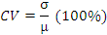

As shown in the following figure, more than the two thirds of the features have a VC not higher than 2 (200%). Note that the examples were extracted from the corpus (TWE: texts without examples).
This may help to find out the core features of the genre:

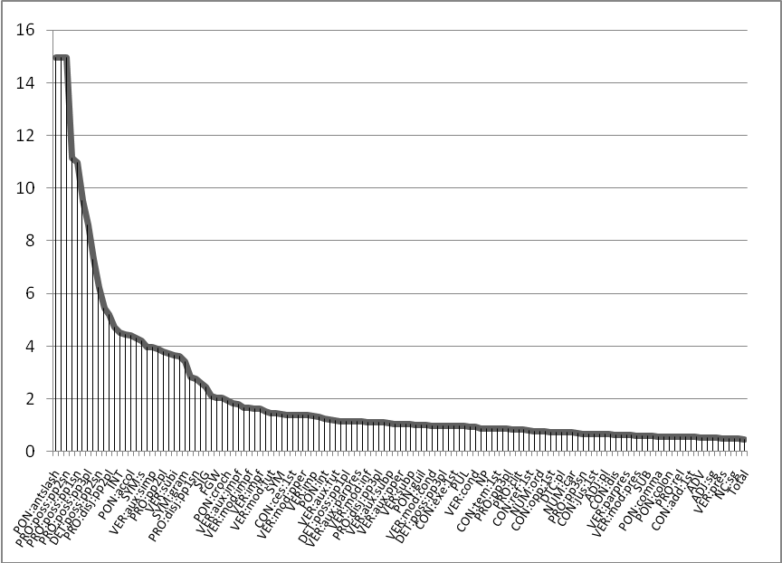
Figure 1 : VC distribution of the features (TWE)

Let us mention that we obtain a similar distribution when we examine the full texts (FT), although the higher variations are, in this case, related to the specificities of the examples (and first of all, to the use of second person pronouns, see below).

The features that have a VC higher than 2 will be considered as less characteristic of the genre. We will first examine the features that vary the most from one text to another.

2.3.2. Principal Component Analysis
The data were then analyzed with a factor analysis (FA) – and more precisely a PCA – to bring out the generic structure of the genre, which was then described in relation with the core features we previously examined.
PCA enables to reveal the interactions between observations and to propose a description of the data able to suggest a structure. It is particularly adapted when we have to deal with a high number of individuals and observations: if we take the example of our data, we consider 224 individuals and 145 features, that is 145 levels of description (number of prepositions, of common nouns and so on). As it would be extremely long to describe the 224 French texts with such a number of levels, we compute a FA and reduce the description space by a smaller number of observations, organized in a linear way, that are called factors.
It is then possible:
- To examine the relations between the texts and to locate the homogeneous groups, as well as the individuals that have untypical behaviour;
- To construct a set of artificial variables (the factors) explaining the descriptors taken into account.
The PCA was computed using DTMVic.

3. In search of the core features of the genre
In order to determine the core features of the genre, we will first consider the descriptors that vary the least from one text to another, using variation coefficients.
Section 3.1. details the linguistic cues that vary the most, and that would be in that respect non characteristic of the genre, whereas section 3.2. describes the most stable features we found out. We finally provide a (rough) description of the genre that we compare with the profile of the pastiche to determine whether the core features we found out were exaggerated (3.3.).

3.1. Non characteristic features
Let us now examine the features that vary the most in the articles:

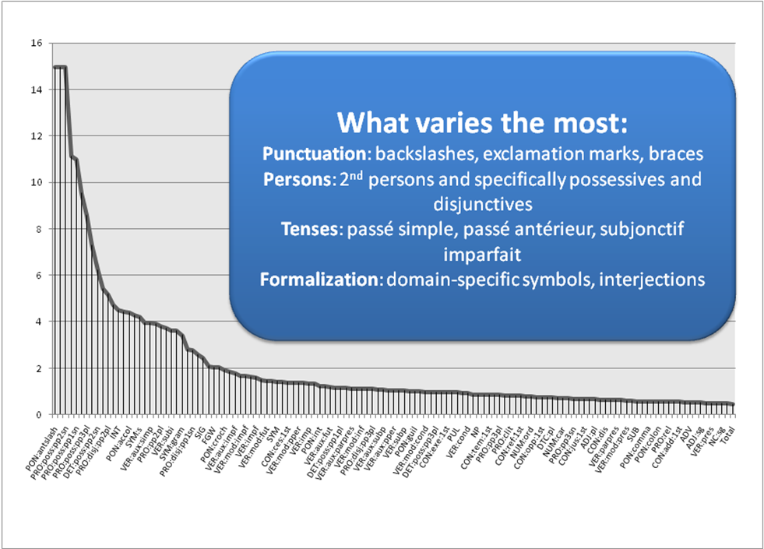
Figure 2 : Features that vary the most

Possessive pronouns such as le mien, le tien, le nôtre… as well as 1st and 2nd person disjunctive pronouns (such as vous, toi, moi) are non surprisingly absent from most of the texts: for instance, possessives could not be found in 90% of the full texts (99% TWE).
Second person pronouns are also definitely non characteristic of the genre (absent from 60% FT / 80% TWE):

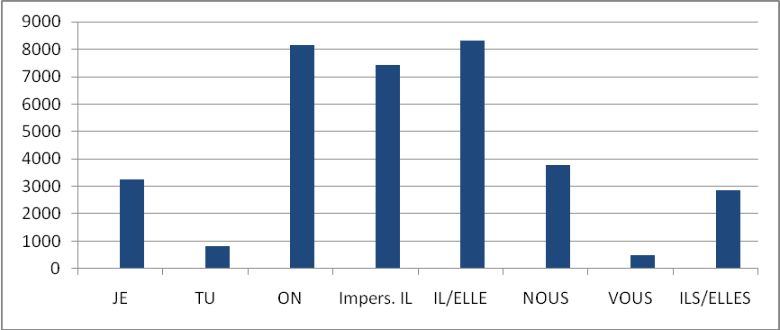
Figure 3: Distribution of personal pronouns (TWE, absolute numbers)

In theory, articles neither contain forms of address to the reader nor interlocutory relations.
The passé simple narrative tense, which contrasts with the universal and timeless scientific discourse, is the tense that varies the most in the texts (VC = 4). More generally, narrative tenses are little used in articles, and can be considered as non specific.
Let us finally mention that backslashes and braces are absent from 90% of the texts: it is interesting to note that linguistic formalizations are rather written with slashes or square brackets.
Subjective punctuations markers such as exclamation or question marks, are also little used, probably because they may hinder the article objectivity.

3.2. Core features
In addition to the general part of speech (i.e. nouns, adjectives or determiners), whose proportions remain identical from one text to another, the following observations turned out to vary the least in the corpus. They may be core features of the genre, as they are almost always represented in the articles in similar distributions:

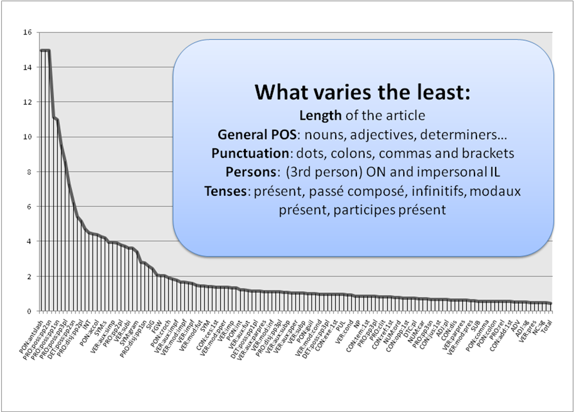
Figure 4 : Features that vary the least

First of all, the article length is quite stable: 7 333 tokens on the average (words and punctuations), that is 19 pages.
Impersonal ON and IL are definitely the most used pronouns. As figure 3 shows, they almost represent half of the personal pronouns used in the texts.
Furthermore, the following bar chart, which is based on the results obtained on the corpus on which Cordial analyseur is trained and developed, clearly shows that dots and commas are invariably the most used punctuation marks as much in essays as in novels or law texts. Colons and brackets are the most significant punctuations used in articles and they are very stable features (VC resp. 0,5/0,6):

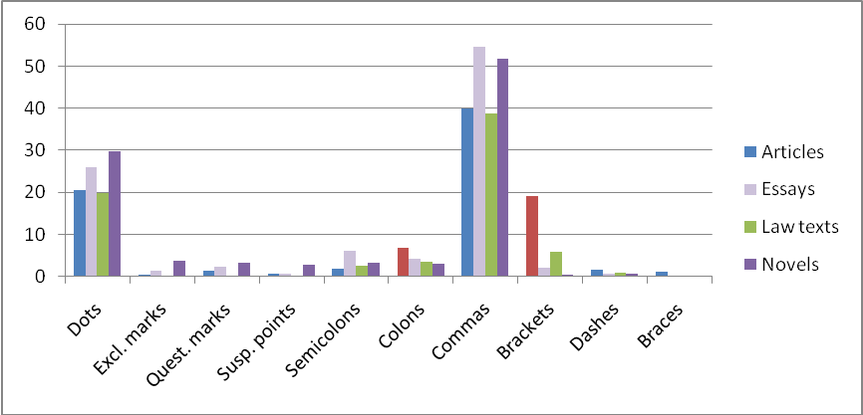
Figure 5 : Distribution of punctuation marks (Cordial annotation)

Let us now consider the tense system of the genre: the present and the present perfect tenses are definitely the most used ones. More than 65% of the verbs are conjugated with the present tense – as the present auxiliaries include both verbs conjugated with the present perfect and passive structures:

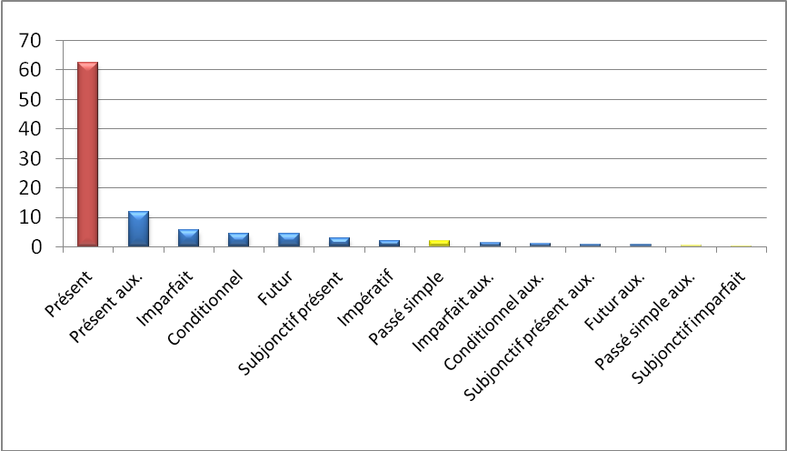
Figure 6: Tense distribution (TWE, percentage)

3.3. Genre and pastiche
Table 2 provides a rough summary of the major characteristics of the genre (contingent and core features), such as it is represented in the corpus:

 | FAL Corpus
Length | ≈ 7333 tokens ≈ 19 pages
Pronouns | Impersonal pronouns ON (23% PP) and impersonal IL (21% PP) vs. 2nd person pronouns TU (2% PP) and VOUS (1% PP)
Punctuations | colons (7% p.) and brackets (19% p.) vs. backslashes, exclamation marks, braces (< 0,5% each)
Tenses | présent (65% conjugated verbs), passé composé and passive structures (12% CV) vs. passé simple (1,8%), passé antérieur (0,26%), subjonctif imparfait (0,25%)  + conditionnel (4,43%), futur (4,39%)
Formalization | domain-specific symbols, interjections
Table 2: Genre characteristics – FAL corpus

The main characteristic features we obtained mostly match intuition. In the literature, scientific style aims at universality and objectivity and the features may be interpreted in that light:
- Scientific discourse is timeless: research articles impact the present, and this is why the texts avoid narrative tenses and are mainly written in the present tense or using present auxiliaries (≈ 80% total);
- Scientific discourse is impersonal and objective : although the first person pronouns JE and NOUS are more and more used for self-reference in academic French, impersonal IL and ON remain the most used subject pronouns. Moreover, subjective punctuations markers such as exclamation marks are avoided as much as possible ;
- Finally, colons, which are very used and stable punctuation marks in the corpus (VC = 0,5), are well known to have a demonstrative value.
The remaining features are domain-specific: backslashes and braces are little used in the corpus, and might be less employed in linguistics than in other disciplines. Moreover, linguistic symbols vary a lot, depending on the linguistic domain to which articles belong to.

By way of experiment, we decided to compare the typical distributions we found out in the FAL corpus with the characteristics of the pastiche:

 | FAL Corpus | Pastiche
Length | ≈ 7333 tokens ≈ 19 pages | ≈ 2690 tokens ≈ 7 pages
Pronouns | Impersonal pronouns ON (23% PP) and impersonal IL (21% PP) vs. 2nd person pronouns TU (2% PP) and VOUS (1% PP) | Impersonal pronouns ON (14% PP) and impersonal IL (28% PP) vs. 2nd person pronouns TU (0% PP) and VOUS (0% PP)
Punctuations | colons (7% p.) and brackets (19% p.) vs. backslashes, exclamation marks, braces (< 0,5% each) | colons (4% p.) and brackets (34% p.) vs. backslashes, exclamation marks, braces (0% each)
Tenses | présent (65% conjugated verbs), passé composé and passive structures (12% CV) vs. passé simple (1,8%), passé antérieur (0,26%), subjonctif imparfait (0,25%)  + conditionnel (4,43%), futur (4,39%) | présent (34% conjugated verbs), passé composé and passive structures (45% CV) vs. passé simple, passé antérieur, subjonctif imparfait (0%)  + conditionnel (0,41%), futur (0%)
Formalization | domain-specific symbols, interjections | domain-specific symbols, interjections (0%)
Table 3: Comparative distributions – FAL corpus / pastiche

The linguistic cues that we found out to vary the most are not represented at all in the pastiche (2nd person pronouns, narrative tenses or exclamation marks for instance). Indeed, pastiches do not exaggerate non characteristic features.
On the contrary, some very stable features are significantly exaggerated: this is the case for present auxiliaries, as passive structures and verbs conjugated with the passé composé tense are clearly and perceptibly over-represented in the text. Passive structures are actually known to be core features of scientific discourse.
Finally, the major differences between the two lie in tense distribution: the past tenses are on the one hand far more represented in the pastiche, especially in the fake state of the art and the report of the experiment. On the other hand, the conditional tense is scarcely used and the future tense is interestingly absent from the text.
The differences can be explained on the one hand by the fact that the pastiche is built as a report, and on the other hand because no research process (and no future of the research) is naturally portrayed.

4. Genre structure and core features
Let us now enter the second part of our investigation in which we focus on the generic structure of scientific articles in connection with the core features of the genre.
We begin by a few remarks on the notion of correlation and its interpretation (4.1.). We then examine the PCA that was computed on the FAL corpus (4.2.) and the position of the pastiche on the factor map (4.3.).

4.1. A few remarks on the notion of correlation and its interpretation
Up to now, we have been focusing on features “in isolation”. The notion of correlation has not been tackled yet although it is crucial to capture and describe genres. The features we previously describe are indeed far from being independent: texts are not bags of words and genres could not be described with lists of words or features.
Genres are multidimensional objects in which linguistic features and levels are intimately correlated: for instance, the WE pronoun is significantly correlated to the future tense in our corpus, and this relates back to a more general reader-friendly dimension.
Keeping in mind that any local form is globally determined, different levels of correlations can be dissociated, depending on the size of the context we consider. Correlations can be computed locally (for instance within the same paragraph, or a narrower window), or globally (within the texts, or even the corpora). In most cases, local correlations (and collocations) – at least the stronger ones – will appear when computing text correlations.
Generally speaking, correlations raise numerous problems of interpretation as any cue might be interpreted through the lens of different levels of linguistic (i.e. syntactic, discursive or semantic) or even social (i.e. authority, community, etc.) phenomena.
Here are some examples of different levels of interpretation using morphosyntactic features:
- Local correlations / collocations: verbs conjugated with the future tense are for instance correlated with the WE pronoun. Example: Nous verrons ultérieusement…
- Grammatical rules: verbs conjugated with the passé simple tense are correlated with verbs conjugated with the imparfait (combination of narrative tenses)
- Text dimensions: verbs conjugated with the future tense are correlated with imperatives, and the correlation relates back to a reader-friendly dimension in the articles.
These remarks are at the heart of the interpretation of factor analysis.

4.2. PCA
Let us examine the first factor map of the PCA computed on the FAL corpus:

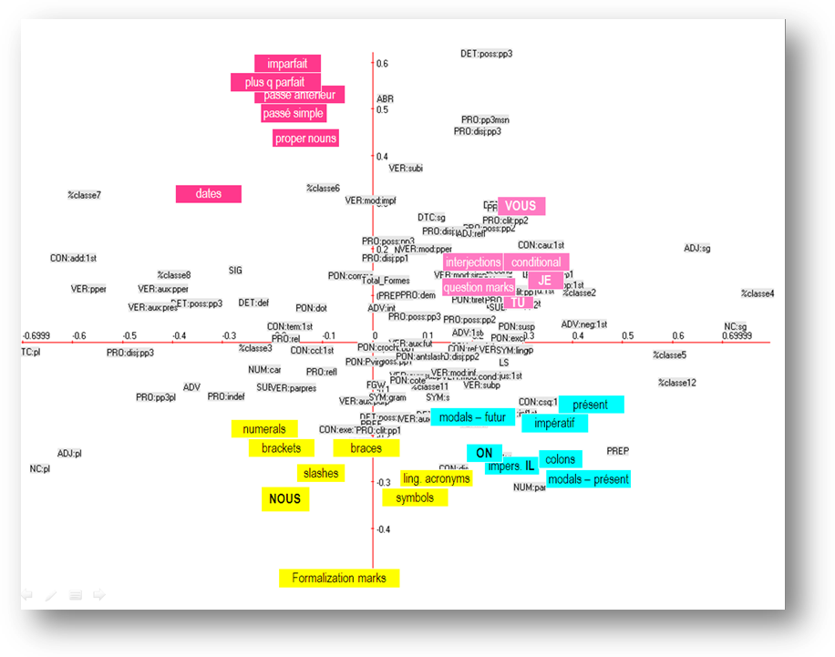
Figure 7: First factor map – FAL Corpus – features

It is firstly quite interesting to note that the core descriptors we observed, including present-oriented tenses, impersonal pronouns and colons are intercorrelated (in blue): they contrast with the narrative tenses we found out to be non characteristic of the genre (in red). The French passé simple and imparfait tenses, and their composed counterparts, are also associated to dates and proper nouns: the dimension is both narrative and historical (historical narratives), and it contrasts on the second axis with another intercorrelated cluster of descriptors related to oral and interlocution (in pink, on the top left of the figure): 1st and 2nd person pronouns, question and exclamation marks, interjections, etc., i.e. descriptors we also found out to be contingent, and non specific.
Another dimension can be finally examined at the bottom of the factor map: formalization marks (in yellow: symbols, linguistic metalanguage, slashs, brackets and braces) are indeed intercorrelated, and the NOUS pronoun is part of the cluster.

If we have a look at the individuals, very few texts are oriented toward the narrative features – the features are indeed contingent. Note that the texts 2 and 46 are outliers; the text 2 is built like a dialogue, whereas the text 46 belongs to the sub-field of history of linguistics, and is written like a narrative, with high proportions of passé simple and imparfait tenses:

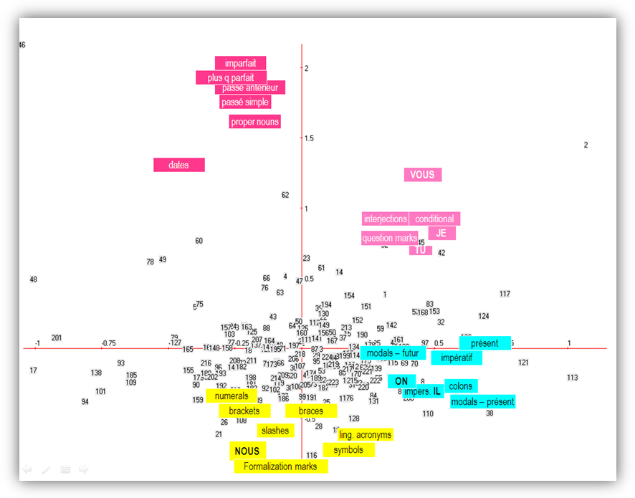
46
2
Figure 8: First factor map – AFC Corpus FAL – individuals

To sum up, four dimensions can be found out: a rhetoric cluster gathering the most stable features of the genre, and three dimensions corresponding to different types of articles and research orientations: (i) historical narratives (epistemological articles), (ii) articles containing interlocution marks, that is linguistic material related to the oral language (discourse, enunciation, conversational pragmatics…) and (iii) formal texts.

4.2. Pastiche
We carried out a last experiment: the pastiche was finally included in the FAL corpus and turned out to be outlier, as shown in the following factor map:

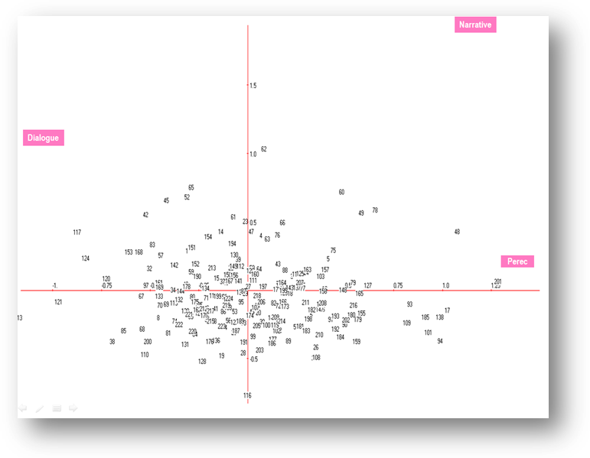
Figure 9: First factor map – AFC Corpus FAL + pastiche – individuals

Compared with the other texts, the pastiche is characterized by a high use of past tenses and plural third person pronouns (les sopranos, les tomates in French).
Finally, let us precise that the four dimensions remain stable with or without the pastiche.

5. Conclusion
Genre impact on the texts is obvious if we consider the stable correlations we identified between low level variables. We have shown how to capture the generic structure of scientific articles, examining variations from one text to another in relation to the correlations that regulate the genre.
The task is not easy, especially because we focus on the research field of linguistics: indeed, most articles describe linguistic phenomena using material that significantly impact the linguistic properties of the texts and the description of the genre – even if we extracted the examples from the articles (see Poudat, 2006 for a detailed description of examples in French linguistics). As a result, the major clusters we obtained reflect sub-domains in the first place, regardless of scientific style. Furthermore, French sub-fields in linguistics are associated with quite different writing traditions (remember the historical narratives).
The use of the pastiche by Perec was quite interesting, as it enabled us to assess the relevance of the tagset we built.

References
Beauvisage, T. (2001) “Exploiter des données morphosyntaxiques pour l’étude statistique des genres textuels : application au roman policier”. TAL, 42, n°2, 579-608.

Biber, D. (1988). Variation across Speech and Writing. Cambridge: Cambridge University Press.

Kando, N. (1999). “Text Structure Analysis as a Tool to Make Retrieved Documents Usable”. Proceedings of the 4th International Workshop on Information Retrieval with Asian Languages, Taipei, Taiwan, 126-135.

Karlgren, J. and Cutting, D. (1994). “Recognizing text genres with simple metrics using discriminant analysis”. COLING 94, Kyoto.

Kessler, B., Nunberg, G. and Schütze, H. (1997). “Automatic Detection of Genre”. Proceedings of the 35th Annual Meeting of the Association for Computational Linguistics and the 8th Meeting of the European Chapter of the Association for Computational Linguistics. San Francisco: Morgan Kaufmann Publishers, 32-38.

Langer, H., Lüngen, H. and Bayerl, P. S. (2004). “Towards automatic annotation of text type structure. Experiments using an XML-annotated corpus and automatic text classification methods ». Proceedings of the LREC-Workshop on XML-based richly annotated corpora, Lissabon.

Malrieu, D. and Rastier, F. (2001) “Genres et variations morphosyntaxiques”. TAL, 42, n°2, 547-577.

Poudat, C. (2003). “Characterization of French linguistic research papers with morphosyntactic variables”. In Fløttum K. & Rastier F. (ed.) Academic discourses — Multidisciplinary Approaches. Oslo: Novus, 77-96.

Poudat, C. (2006). “Étude contrastive de l'article scientifique de revue linguistique dans une perspective d'analyse des genres”. Texto!, XI, n°3-4.
Available at http://www.revue-texto.net/1996-2007/Corpus/Corpus.html (accessed 30 september 2009).

Rastier, F. (2001). Arts et Sciences du texte. Paris: Presses Universitaires de France.

Swales, J. (1990). Genre Analysis: English in Academic and research settings. Cambridge: Cambridge University Press.

The French original text is available on http://www.pianotype.net/doc/tomatotopic.htm and a translation in English can be found on http://pauillac.inria.fr/~xleroy/stuff/tomato/tomato.html.
Detailed in Poudat, 2006.
In the existing literature.
http://ses.telecom-paristech.fr/lebart/05_Software.html
Following the international standards.
The analysis of the 40 first eigen values indicate that the two first factors are the most individualized, whereas the factors 3 and 4 overlap widely.

