Corpus profiling with the Posit tools

George R. S. Weir
Department of Computer and Information Sciences
University of Strathclyde
george.weir@cis.strath.ac.uk

1. Introduction
A common activity in corpus linguistics is the comparison of one corpus with another. Sometimes, this relies on the presumption that the comparator serves as a reference standard and is representative, in some significant manner, of texts (or language) in general. The sample corpus may then be scrutinised in order to determine how or the extent to which it varies from 'the norm'. In other contexts, the aim is simply to contrast several example text collections, in search of significant similarities or differences between them.
Of course, there are many possible dimensions for corpus comparison and their selection usually depends upon specific practical objectives, such as language translation, authorship confirmation, genre classification, etc. The present paper describes recently developed software tools for textual analysis (Posit) and focuses on their use in corpus comparison. The Posit system is primarily designed to analyse corpus content in terms of parts-of-speech (POS), word and n-gram frequency. An extension to the system allows for easy comparison of POS, word and n-gram frequency profiles between corpora. Thereby, Posit affords useful facilities for shedding light on these dimensions of comparison between corpora. The extensive system output includes pie charts to display distributions of major parts-of-speech and a concordance feature to display word contexts for individual corpora. Further display features, including line graph projections for comparisons across corpora, are under development.

2. The Posit tools
In its initial development, the Posit system was designed as a modular script-based facility that allows for easy interfacing to other software applications. Posit is able to handle arbitrarily large corpora and may be controlled from a command-line (Weir, 2007). In its present (second) generation, the Posit system is driven through a graphical user interface and includes additional features, such as concordance display, the choice of using internal, external POS tagger or pre-tagged corpora, and the option of outputting results to an integrated SQL database (Baillie & Weir, 2008).
Primarily, Posit focuses on two aspects of textual analysis: parts-of-speech and vocabulary. Allied to these is the objective to apply these analyses toward the measurement of readability (cf. Anagnostou & Weir, 2008). The data generated by Posit provides a part-of-speech profile and a vocabulary profile for any given corpus. Readability profiling is still under development.

2.1 Word profiling
When a text corpus is analysed, Posit provides a detailed account of word occurrences, by raw frequency and by part-of-speech frequency. Totals are given for:

- word tokens
- word types
- part-of-speech types
- part-of-speech tokens
- type/token ratio
- number of characters
- number of sentences
- average sentence length
- average word length

In addition, optional syllable-based analysis provides for calculations of Flesch Reading Ease and Flesch-Kincaid Grade Level.
In this data output, three levels of detail are provided. At the highest level of abstraction, a summary of the corpus POS profile is generated (Table 1). This single summary file lists the total number of types, tokens, total number of nouns, verbs, adjectives, etc.

INPUT FILENAME: | emma.txt | POS TYPES |  | POS TOKENS
Total tokens: | 159826 | nouns: | 4268 | nouns: | 69060
Total unique types: | 7364 | verbs: | 2603 | verbs: | 67678
Type/Token Ratio: | 21.7 | adjectives: | 1346 | prepositions: | 38600
Number of sentences: | 8585 | adverbs: | 487 | personal pronouns: | 31192
Average sentence length: | 18.61 | prepositions: | 65 | determiners: | 26178
Number of characters: | 914519 | personal pronouns: | 23 | adverbs: | 25432
Average word length: | 5.72 | determiners: | 18 | adjectives: | 25086
 |  | possessive pronouns: | 7 | possessive pronouns: | 9582
 |  | interjections: | 5 | interjections: | 516
 |  | particles: | 0 | particles: | 0
Table 1. Example summary data
(for Jane Austen’s ‘Emma’)

A second level of detail is afforded by ‘aggregated’ data. This indicates for each major part-of-speech, how many component types are present in the analysed corpus. For example, with the total number of nouns, the system indicates how many of these are common nouns (singular), proper nouns (singular), common nouns (plural) and proper nouns (plural). For verbs, as well as the total number of verbs, we have aggregated figures for the number of base form verbs, gerund form verbs, past form verbs, past participle form verbs, present (3rd form) verbs, present (not 3rd form) verbs, and modal auxiliary verbs (Table 2). Similar aggregate data is generated for adjectives, adverbs and pronouns.

verbs base form | 592
verbs gerund form | 483
verbs past form | 470
verbs past participle form | 672
verbs present 3rd form | 170
verbs present not 3rd form | 204
modal aux | 12
Total | 2603
Table 2. Example aggregated verb data
(for Jane Austen’s ‘Emma’)

At the most detailed level of analysis, the system lists the total number of occurrences for each part-of-speech token and type, with words ordered by frequency of occurrence and frequency is included within the data (Table 3). Note that, while these particular examples are not case sensitive, case sensitivity in any corpus analysis can be set by the user.

more | 412 | lower | 4 | thinner | 1
less | 45 | fewer | 4 | taller | 1
better | 45 | elder | 4 | steeper | 1
greater | 29 | softer | 3 | steadier | 1
worse | 27 | louder | 3 | quicker | 1
happier | 11 | fuller | 3 | poorer | 1
higher | 10 | clearer | 3 | nicer | 1
stronger | 8 | younger | 2 | narrower | 1
older | 8 | smaller | 2 | milder | 1
larger | 8 | deeper | 2 | lighter | 1
warmer | 6 | darker | 2 | faster | 1
safer | 5 | calmer | 2 | easier | 1
kinder | 5 | broader | 2 | colder | 1
wiser | 4 | weaker | 1 | closer | 1
Table 3. Example detailed ‘adjective comparatives’ data
(for Jane Austen’s ‘Emma’)

2.2 Vocabulary profiling
In addition to the word frequency data noted above, Posit extends its vocabulary analysis to consider n-gram frequencies within the analysed corpus. Currently, the system generates frequency lists for 2-grams, 3-grams and 4-grams. Table 4 gives an example ‘top ten’ n-gram frequency results.

2-gram | Frequency | 3-gram | Frequency | 4-gram | Frequency
to be | 608 | i do not | 136 | i do not know | 50
of the | 566 | i am sure | 109 | a great deal of | 26
it was | 449 | she could not | 73 | i am sure i | 20
in the | 446 | a great deal | 64 | it would have been | 19
i am | 395 | it would be | 63 | mr and mrs weston | 18
she had | 334 | would have been | 60 | it would be a | 18
she was | 331 | it was not | 55 | i do not think | 18
had been | 308 | do not know | 55 | i have no doubt | 16
it is | 301 | she had been | 53 | i am sure you | 16
mr knightley | 299 | it was a | 53 | and i am sure | 15
Table 4. Example n-gram data (for Jane Austen’s ‘Emma’)

Such word combination frequency analysis can also be generated for n-grams tagged with parts-of-speech.

3. User interface
Posit’s graphical user interface (GUI) provides an intuitive and user-friendly means of driving the underlying scripts. The GUI version also supports the ability to configure and execute multiple projects simultaneously in the same environment; a corpus concordance feature; an enhanced results database with search facilities; an extensive help system; context-sensitive tool tips; and, generally, enhanced interaction through shortcut toolbar buttons and menu accelerators.
The graphical user interface provides a means for configuring every feature covered by the scripts. This is achieved through file choosers, checkboxes, drop-down menus and input fields (Figure 1) which make changes to a model representation of a script configuration file. Such models can be saved to a named configuration file for later reload. All configuration changes are recorded by a logging system, output from which is available to the user.

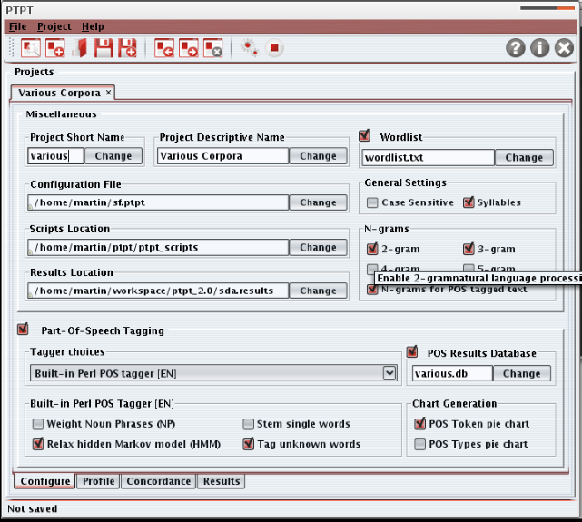
Figure 1. Configuration screen

Once a project is configured, it is possible to execute the scripts with the selected configuration. Prior to executing, the interface saves the current settings to a configuration file of the user’s choice. This ensures that the visual configuration reflects that which is passed to the scripts. During execution, the interface will display exactly what is happening in the underlying scripts through the graphical run console (Figure 2), and the process can be stopped at any time. Progress is measured and reported to the user via a percentage progress bar. If the execution momentarily stalls, e.g., following a call to an external program, an ‘indeterminate’ progress bar is used to indicate this fact.

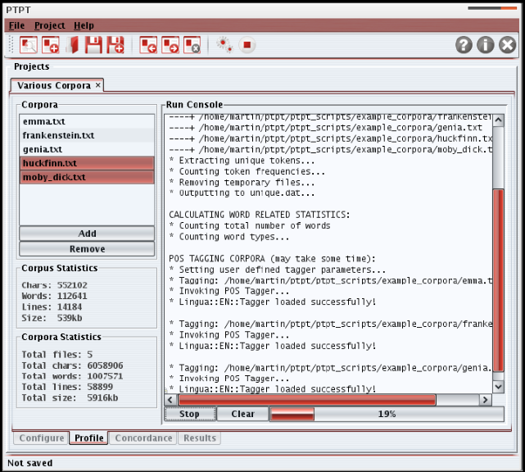
Figure 2: Run Console in the Profile Window

Since the primary purpose of the GUI version is to afford easier access to Posit facilities, the standard Posit tools are supported through the new interface. For instance, part-of-speech (POS) tagging is optionally available and results from the tagging and subsequent frequency analysis are placed in the same output file regime as in the original Posit system. Creation of n-gram frequency lists is also included as an easily managed option through the graphical interface. Results from the n-gram analyses can be viewed through the in-built file viewer (Figure 3) which also supports text searches on the displayed results.

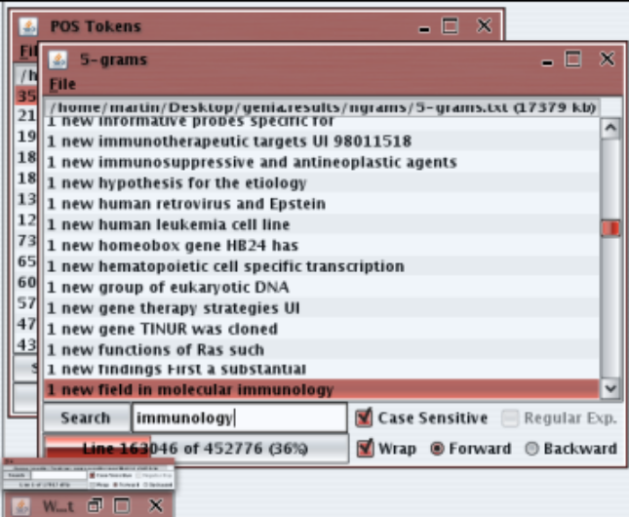
Figure 3. Displaying n-gram results

3.1 GUI features
A range of new features have been added to the core Posit functionality through the GUI development. The principal additions are:

- Results database
- Optional POS tagging and support for multiple taggers and pre-tagged text
- Concurrent profile execution
- Concordance

3.1.1 Results database
Inclusion of a relational database solution for storing the results of word/POS tag frequency analyses affords a powerful new addition to the Posit features. Addition of this database facility does not require any extra software packages to be installed on the end user's system. Derby, an Apache DB Project, proved to be ideal for this purpose. This is a commercial-quality, open-source relational database written entirely in Java and based on SQL standards that can be embedded in any Java application. In addition to this, Derby has a small memory footprint and has little performance effects on the toolset application. Through this facility a user may perform searches across numerous results files and cross reference words to determine the grammatical types under which they have been categorised and in what contexts they are used within the test corpora (Figure 4).

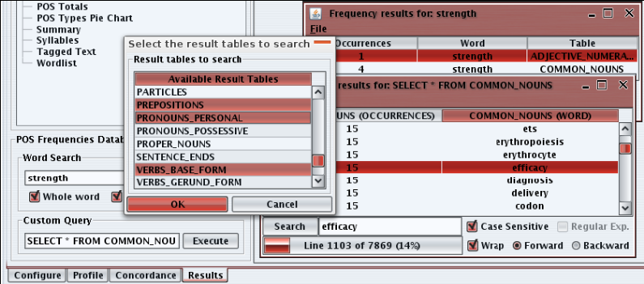
Figure 4. Database search facility

3.1.2 Optional POS tagging
Since most script features are configurable, the GUI also allows the user to configure the POS tagging. As well as turning POS tagging off altogether, thereby accommodating pre-tagged texts, the user may opt to change from one POS tagger to another. The application comes with two POS taggers but, through the addition of wrapper scripts, also allows for the use of external POS taggers.

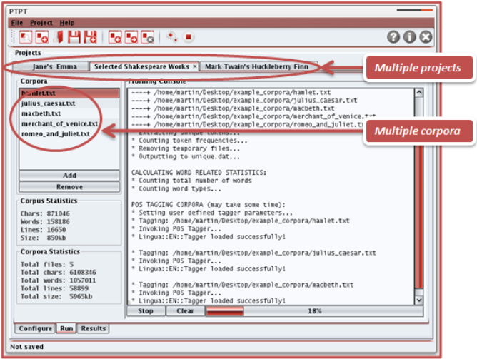
Figure 5. Managing multiple projects

3.1.3 Concurrent profile execution
This useful new facility allows the user to perform simultaneous independent analyses on two or more sets of texts and manage the profiles and results through separately specified project windows (Figure 5). Each profile will have its own set of configuration, profile, concordance and results windows. Although processed independently, the concurrent availability of separate sets of results will facilitate ease of visual comparison across the analysed text corpora.

3.1.4 Concordance
The concordance feature adds a common and useful textual analysis component that was absent from the original Posit tools. Through the concordance a user can select a keyword and the desired word span on either side of the keyword. The system will then display all occurrences of the keyword in the contexts provided by the surrounding number of adjacent words. The concordance feature is illustrated in Figure 6. With the addition of a concordance, the Posit Toolset becomes one of the most versatile and complete textual analysis tools available.

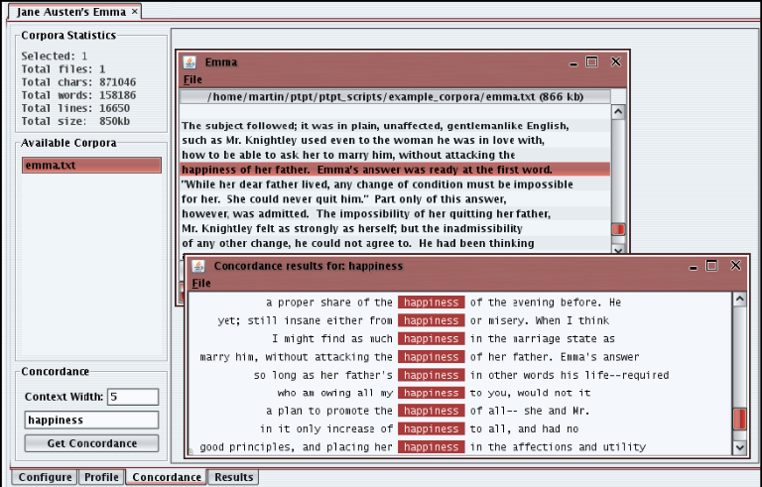
Figure 6. Concordance feature

Concordance searching is an interactive feature that is performed on the loaded corpora. The concordance facility is provided in a separate tab and concordance results are displayed in a file viewer similar to that of the Results tab. This also allows the user to have many concordance result windows open simultaneously for comparison purposes. The concordance results can also be saved as an HTML file for subsequent viewing as a 'webpage' within the Posit tool or through a Web browser.

4. Conclusion
The Posit toolset is a fully-fledged graphical textual analysis toolkit. It accommodates the inherent cross-compatible nature of the original Posit toolset and makes it more accessible to a variety of users. The toolset is now a highly configurable and customisable set of standardised UNIX scripts and there is now a lightweight, GUI which can graphically configure, execute and display the results of the underlying scripts. With the interface come additional benefits including: multiple simultaneous executions, result and database searching, concordancing and a full help system including context sensitive tooltips for every component. The package is complete and portable and has been tested on Linux, UNIX, and Mac OS X. A version for Microsoft Windows is presently under development.
We have already applied the Posit tools as a means of shedding light on newspaper corpus data (Weir & Anagnostou, 2008), and also in contrasting Japanese historical EFL texts (Weir & Ozasa, 2008, 2009). We believe that there are countless potential applications and recommend the Posit tools for use in contrastive corpus research. (The Posit tools are freely available to members of the research community upon application to the author.)

References
N. K. Anagnostou and G. R. S. Weir (2008). “Average Collocation Frequency as an Indicator of Semantic Complexity”. In Studies in Language and Textbook Analysis. Edited by G. R. S. Weir and T. Ozasa. University of Strathclyde Publishing, Glasgow, UK, 53-58.
Baillie, M. and Weir, G. R. S. (2008). “The Posit Toolset with Graphical User Interface”. Proceedings of the 4th International ICTATLL Workshop, Sri Lanka.
Weir, G. R. S. (2007). “The Posit Text Profiling Toolset”. Proceedings of the 12th Conference of Pan-Pacific Association of Applied Linguistics. Pan-Pacific Association of Applied Linguistics, Thailand.
G. R. S. Weir and N. K. Anagnostou (2008). “Exploring newspapers: a case study in corpus analysis”. In Studies in Language and Textbook Analysis. Edited by G. R. S. Weir and T. Ozasa. University of Strathclyde Publishing, Glasgow, UK, 21-28
Weir, G. R. S. and Ozasa, T. (2008). “Multiword vocabulary in Japanese ESL texts”. Proceedings of the 13th Conference of Pan-Pacific Association of Applied Linguistics. Pan-Pacific Association of Applied Linguistics, Hawaii.
Weir, G. R. S. and Ozasa, T. (2009). “Verb form usage in Japanese EFL Texts”. Proceedings of the 14th Conference of Pan-Pacific Association of Applied Linguistics. Pan-Pacific Association of Applied Linguistics, Kyoto.

